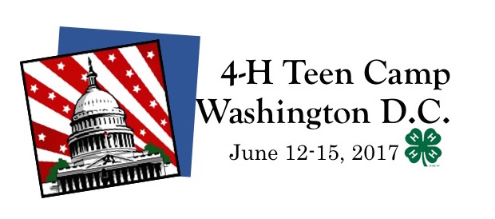
Registration
Due
May 1, 2017
This exciting camp for our teen 4-H members will take us to Washington D.C.! Join us as we learn about our country’s history and government with fellow 4-H members from Alleghany, Buncombe, Davidson, Gaston, McDowell and Surry Counties. Activities will include tours of the Capitol, National Monuments, Arlington National Cemetery, National Zoo, Smithsonian Museums, the Supreme Court and much more! We are also planning some great leadership/team building workshops and special!

Name: |  | Age: |  | Gender: F M |  |  | DOB:
Address: |  | County: |  |  |  |  | Grade:
City: |  |  | State: |  |  | Zip:
Home Phone: | Work Phone: |  |  |  | Cell:
(for White House Tour)
Email: Social Security #
Allergies:
Dietary Needs:

Parent(s)/Guardian(s):

AGES: Participants should be 13 years old by January 31, 2017

COST $250 which covers all tours, transportation, lodging, breakfasts and dinners. Participants must bring money for lunches and souvenirs. ($50 deposit due at time of registration. Balance due by May 15. Registrations canceled by June 2nd will receive a 50% refund. Cancellations after June 2nd will not receive a refund, however same-gender substitutions can be made.)

Make Checks Payable To: “ Alleghany 4-H ”

Registration Due: Registration will be taken on a first come-first served basis. Spaces are limited so registration will be accepted until spaces are filled which may be prior to the deadline. Return this as well as the following forms to your County 4-H Program/North Carolina Cooperative Extension office in your county no later than May 1, 2017.

Forms to include:
- NC 4-H Medical Release Form (must be notarized)
- NC 4-H Media Release Form

Please initial:
I understand that compliance with the NC 4-H Code of Conduct and Disciplinary Procedure is a condition of participation in 4-H events.
For questions or more information please contact _Amy Lucas at (336) 372-5597 or amy_lucas@ncsu.edu.

